D21/167763-RPI17/001 - SUPPORTING AMENDMENT DOCUMENTS
WORD DOCUMENT DETAILING AMENDMENTS
- Summary of Amendment Change to Infrastructure
- Reason for Amending the Infrastructure Locations
- Regional interests conditions (amended)
- Attachment A - Description of the subject land: (no change)
- Approved activities : Attachment 1 - Table 1 (amended)
- Definitions: Attachment 1 – Table 2 (amended)
- Map Attachment 2: 2021 Approved plans and specifications
- Map Attachment 2: 2023 Approved plans and specifications

- Summary of Amendment Change to Infrastructure

Minor amendments to the approved 2021 D21/167763; RPI17/001– Mount Morgan Mine Site as follows:

Item 1: Construct and operation of a modular Pilot Water Treatment Plant adjacent to the approved new mine lease access road from Gordon Lane;

Item 2: Relocate from the Process Plant location to the above Gordon Lane mine access road location - construction of an Administration, Security and Laboratory building;

Item 3: Relocate from the Process Plant location a Carpark at the above location (in addition to the Gordon Lane mine access road Carpark as previously approved);

Item 4: Upgrade an existing internal former mine haul road and light vehicle access road north of the Open Cut Pit;

Item 5: Civil works to prepare a mine equipment park-up area including construction of a Workshop adjacent to the above mine haul road on the north of the Open Cut Pit. These facilities were previously planned for within the Process Plant location.

- Reason for Amending the Infrastructure Locations

Item 1: To test at pilot plant scale an innovative water treatment process that may assist in the long-term management of Acid Mine Drainage at the Mount Morgan Mine Site.

Item 2: The Administration and Laboratory Building was previously located within the Process Plant location as approved in the 2021 RPI17-001 Priority Living Area amendment. Relocation adjacent to the Gordon Lane mine access road will provide a safer operating environment by removing the need for administration and laboratory staff to interact with the Process Plant. There is no change to the Lot and Plan area as this is a relocation within the relevant Lot.

Item 3: An additional Carpark at the above location will improve site safety and security. It reduces vehicle traffic at the Process Plant location. There is no change to the Lot and Plan area as this is a relocation within the relevant Lot.

Item 4: A mine haul road to the north of the Open Cut Pit reduces impact to heritage listed features south of the Open Cut Pit and is further removed from the community.

Item 5: A mine equipment park-up area and associated workshop facility reduces impact within the heritage listed area and is located further from community view and any potential impact.

Heritage Minerals believes that the infrastructure amendments as listed (Items 1 to 5) can operate within the conditions approved in the RDIA permit RPI17/001 issued to Heritage Minerals in September 2021 as follows:

AMENDED REGIONAL INTERESTS DEVELOPMENT APPROVAL February 2023 (RIDA)
RPI17/001 Norton Gold Fields Limited Heritage Minerals – Mount Morgan Mine Project
(Given under the Regional Planning Interests Act 2014 section 53)

Description of the land
Real property description: Refer to Attachment A
Local Government Area: Rockhampton Regional Council

Approved activities
The approved activities are set out in Table 1 of Attachment 1.

Definitions of the resource activities are included in Table 2 of Attachment 1.

This development approval authorises impacts on a Priority Living Area (PLA) by the approved activities.

General Advice
It is the applicants’ responsibility prior to works commencing on site to ensure all relevant approvals and licenses are obtained from the applicable Local, State, and/or Federal Authorities. This includes but not limited to approvals required under Nature Conservation Act, 1992; Aboriginal Cultural Heritage Act, 2003 and Environmental Protection and Biodiversity Conservation Act, 1999.

Regional interests conditions
A person who is the holder of, or is acting under, this RIDA must not contravene a condition of this approval.

Condition number | Condition | Timing for condition
1. | Carry out the approved activity generally in accordance with:  - The activities identified in Table 1: Approved activities (refer Attachment 1)  - The activities defined in Table 2: Definitions of Activities (refer Attachment 1)  - The locations as shown on approved plan: | At all times.

 | - Carbine Resource Activity Heritage Minerals by Lot and Plan (Amended), dated 17/03/2017 February 2023 (refer Attachment 2).
2. | - All complaints received, and resulting actions taken, about the impact of the approved activities on the attributes of the PLA must be recorded. The record must include:  - name, address and contact number of the complainant  - time and date of complaint  - reasons for the complaint  - investigations undertaken  - conclusions formed  - actions taken to resolve the complaint  - any abatement measures implemented  - person responsible for resolving the complaint.  - The records of any complaints received and recorded in accordance with this condition must be provided to the chief executive at RPIAct@dsdilgp.qld.gov.au and quoting RPI17- 001. | - At all times.  - Within three business days of receipt of a complaint.
3. | A full copy of the regional interest development approval must be kept on-site and available to any person(s). | At all times.
4. | Undertake road upgrade works for the local government road network at the locations set out in Table 1 of the Haul Route Road Impact Assessment, prepared by McMurtrie Consulting Engineers, dated 18 April 2017 and generally in accordance with the following plans for each respective location (refer Attachment 2):  Gordon Lane and Proposed Internal Road Intersection – Swept Path and Roadworks Layout Plan – Sheet 2 of 2, prepared by McMurtrie Consulting Engineers, drawing number 1021617-6002, dated 13/04/2017, revision A; Creek Street Reverse Curves – Roadworks Layout Plan – Sheet 1 of 2, prepared by McMurtrie Consulting Engineers, drawing number 1021617-2001, dated 13/04/2017, revision A;  Creek Street Reverse Curves – Roadworks Layout Plan – Sheet 2 of 2, prepared by McMurtrie Consulting Engineers, drawing number 1021617-2002, dated 13/04/2017, revision A;  Razorback Road Jump Up – Roadworks Layout Plan – Sheet 1 of 2, prepared by McMurtrie Consulting Engineers, drawing number 1021617-1001, dated 13/04/2017, revision A;  Razorback Road Jump Up – Roadworks Layout Plan – Sheet 2 of 2, prepared by McMurtrie Consulting | Prior to commencement of any haulage from the site.

Engineers, drawing number 1021617-1002, dated 13/04/2017, revision A;
Razorback Road Jump Up – Road Cross Sections – Sheet 1 of 10, prepared by McMurtrie Consulting Engineers, drawing number 1021617-1101, dated 13/04/2017, revision A;
Razorback Road Jump Up – Road Cross Sections – Sheet 2 of 10, prepared by McMurtrie Consulting Engineers, drawing number 1021617-1102, dated 13/04/2017, revision A;
Razorback Road Jump Up – Road Cross Sections – Sheet 3 of 10, prepared by McMurtrie Consulting Engineers, drawing number 1021617-1103, dated 13/04/2017, revision A;
Razorback Road Jump Up – Road Cross Sections – Sheet 4 of 10, prepared by McMurtrie Consulting Engineers, drawing number 1021617-1104, dated 13/04/2017, revision A;
Razorback Road Jump Up – Road Cross Sections – Sheet 5 of 10, prepared by McMurtrie Consulting Engineers, drawing number 1021617-1105, dated 13/04/2017, revision A;
Razorback Road Jump Up – Road Cross Sections – Sheet 6 of 10, prepared by McMurtrie Consulting Engineers, drawing number 1021617-1106, dated 13/04/2017, revision A;
Razorback Road Jump Up – Road Cross Sections – Sheet 7 of 10, prepared by McMurtrie Consulting Engineers, drawing number 1021617-1107, dated 13/04/2017, revision A;
Razorback Road Jump Up – Road Cross Sections – Sheet 8 of 10, prepared by McMurtrie Consulting Engineers, drawing number 1021617-1108, dated 13/04/2017, revision A;
Razorback Road Jump Up – Road Cross Sections – Sheet 9 of 10, prepared by McMurtrie Consulting Engineers, drawing number 1021617-1109, dated 13/04/2017, revision A; and
Razorback Road Jump Up – Road Cross Sections – Sheet 10 of 10, prepared by McMurtrie Consulting Engineers, drawing number 1021617-1110, dated 13/04/2017, revision A.
4. | Carry out the following works:  - Sealing of the internal road from the property boundary access for a distance of 350m along the internal haul access road;  - Construction of mine access, signage, and widening works to a BAR/BAL standard on Gordon Lane, generally in accordance with McMurtrie Consulting Engineering Drawing 1021617-1009 Rev A dated 13/04/2017; | Prior to commencement of any haulage from the site.

- Alteration of line marking at the intersection of Gordon Lane / Burnett Highway generally in accordance with the McMurtrie Consulting Engineering Drawing Number 1021617-5002 Rev A dated 13/04/2017;
- Road widening and sealing at the north eastern corner of the intersection of Burnett Highway / Creek Street / Razorback Road to facilitate right turn movements out of Creek St / Razorback Road, generally in accordance with McMurtrie Consulting Engineers Drawing Number 1021617-7002 Rev A dated 13/04/2017.
5. | Provide written notification to Rockhampton Regional Council at enquiries@rrc.qld.gov.au (and quoting RPI17-001, application D8-2017) when the transportation of material extracted from the site is to commence. | Prior to commencement of any haulage from the site.
6. | Provide documentation to Rockhampton Regional Council (such as weigh bridge statements or similar) verifying the quantity of material that is extracted and transported from the site. The information is to be provided to Rockhampton Regional Council at enquiries@rrc.qld.gov.au and quoting RPI17-001, application D8-2017. | First day of every sixth month period of the mine operations, from the commencement of the haulage operations until the haulage operations cease.
7. | Pay a monetary contribution to Rockhampton Regional Council (quoting RPI17-001, application D8-2017) towards increased maintenance and rehabilitation of the local government road network within the PLA at a rate of $0.433 $0.0523 per tonne of material hauled on the local road network in accordance with the Amended Traffic Impact Assessment (Rev A) by McMurtrie Consulting Engineers dated 21 May 2021.  Note: This monetary contribution shall be indexed based on the Road and Bridge Construction Index, Queensland – Class 3101, published quarterly by the Australian Bureau of Statistics (ABS Cat No. 6427, Series ID A2333727L) to the date of payment. | First day of every sixth month period of the mine operations, from the commencement of the haulage operations until the haulage operations cease.
8. | Undertake road upgrade works for the State controlled network at the locations set out in Table 1 of the Haul Route Road Impact Assessment, prepared by McMurtrie Consulting Engineers, dated 18 April 2017 and generally in accordance with the following plans for each respective location (refer Attachment 2):  Burnett Highway and Gordon Lane Intersection – Swept Path and Roadworks Layout Plan – Sheet 2 of 2, | Prior to commencement of any haulage from the site.

prepared by McMurtrie Consulting Engineers, drawing number 1021617-5002, dated 13/04/2017, revision A; and
Burnett Highway and Razorback Road Intersection – Swept Path and Roadworks Layout Plan – Sheet 2 of 2, prepared by McMurtrie Consulting Engineers, drawing number 1021617-7002, dated 13/04/2017, revision A.
9. 8. | Provide documentation to Department of Transport and Main Roads (such as weigh bridge statements or similar) verifying the quantity of material that is extracted and transported from the site (and onto the state-controlled road network). The information is to be provided to Transport and Main Roads at fitzroydistrict@tmr.qld.gov.au and quoting RPI17-001, reference number TMR20-031707. | First day of every sixth twelfth month period of the mine operations, from the commencement of the haulage operations until the haulage operations cease.
10.9. | Pay a monetary contribution to the Department of Transport and Main Roads (contact fitzroydistrict@tmr.qld.gov.au and quoting RPI17-001, reference number TMR20-031707) towards increased maintenance and rehabilitation of the State-controlled Road network within the PLA at a rate of:  $0.6302 per tonne of material hauled on State- controlled roads.  - $10,273.00 (once off); and  - $4,342.00 per annum thereafter.  Note: This monetary contribution shall be indexed based on the Road and Bridge Construction Index, Queensland – Class 3101, published quarterly by the Australian Bureau of Statistics (ABS Cat No. 6427, Series ID A2333727L) to the date of payment. | First day of every sixth twelfth month period of the mine operations, from the commencement of the haulage operations until the haulage operations cease.
11.10 | There must be no worsening to the water quantity and quality coming out of the mine site post development compared to that of the pre-development scenario in accordance with the Environmental Authority Amendment approval. | At all times.

Attachment A: Description of subject land

Part of Lot 107 on CP881492 - Private Rolling Term Lease (S C Larson and T A Larson); Part of Gordon Lane (D) – Rockhampton Regional Council;
Lot 1 on MPH11169 - Rockhampton Regional Council;
Part of Lot 203 on RN1556 (A, B, C, D and E) - Rockhampton Regional Council; Part of USL Meinberg Crossing Dee River – State of Queensland;
Part of USL Mundic Creek - State of Queensland; Part of USL Shepherd Gully - State of Queensland; Part of USL Dee River - State of Queensland;
Part of Lot 1 on RP860374 (includes off lease haul route) - State of Queensland; Lot 3 on RP601353 - State of Queensland;
Lot 3912 on MPH10386 - State of Queensland; Lot 1 on MPH10729 - State of Queensland;
Part of Lot 1 on MPH10396 - State of Queensland; Lot 1 on MPH10479 - State of Queensland;
Part of Lot 1 on MPH10827 - State of Queensland; Lot 1 on MPH10850 - State of Queensland;
Part of Lot 1 on MPH10966 - State of Queensland; Lot 1 on MPH11057 - State of Queensland;
Lot 2 on MPH11057 - State of Queensland; Lot 1 on MPH11115 - State of Queensland;
Part of Lot 1 on MPH11627 - State of Queensland; Part of Lot 1 on MPH11642 - State of Queensland; Lot 1 on MPH11780 - State of Queensland;
Part of Lot 1 on MPH12108 - State of Queensland; Lot 1 on MPH12202 - State of Queensland;
Lot 1 on MPH25348 - State of Queensland; Lot 1 on MPH25461 - State of Queensland;
Part of Lot 1 on MPH25473 - State of Queensland; Lot 1 on MPH25494 - State of Queensland;
Part of Lot 102 on USL42977 - State of Queensland; Part of Lot 3 on USL42977 - State of Queensland;
Part of Lot 103 on USL42977 (A, B, C) - State of Queensland; Lot 118 on USL42984 - State of Queensland;
Lot 1197 on MPH25518 - State of Queensland; Part of Lot 12 on USL47036 - State of Queensland; Lot 1341 on MPH25518 - State of Queensland;
Lot 1342 on MPH25518 - State of Queensland; Lot 1463 on MPH10760 - State of Queensland; Lot 17 on USL42984 - State of Queensland; Lot 2 on MPH10850 - State of Queensland; Lot 2 on MPH11057 - State of Queensland; Lot 1 on MPH11057 - State of Queensland;
Part of Lot 2 on MPH25461 - State of Queensland
Part of Lot 2452 on MPH11067 - State of Queensland; Lot 3273 on MPH11435 - State of Queensland;
Lot 3274 on MPH11435 - State of Queensland;
Part of Lot 3275 on MPH11435 - State of Queensland; Part of Lot 3276 on MPH11435 - State of Queensland; Lot 3469 on MPH11435 - State of Queensland;
Part of Lot 5164 on MPH10386 - State of Queensland; Lot 3912 on MPH10386 - State of Queensland;
Lot 6 on USL42977 - State of Queensland; Lot 69 on USL42977 - State of Queensland; Lot 60 on USL42977 - State of Queensland; Lot 63 on USL42977 - State of Queensland; Lot 64 on USL42977 - State of Queensland; Lot 65 on USL42977 - State of Queensland; Lot 66 on USL42977 - State of Queensland; Lot 67 on USL42977 - State of Queensland; Lot 68 on USL42977 - State of Queensland; Lot 77 on USL42977 - State of Queensland; Part Lot 90 on P42319 - State of Queensland;
Part Lot 19 on RP602104 - State of Queensland; Part Lot 18 on RP602104 - State of Queensland; Part Lot 17 on RP602104 - State of Queensland;
Part Easement A in Lot 203 on RN1556 on SP164788 – Telstra Corporation Ltd on State land and Rockhampton Regional Council land;
Easement B in Lot 1 on RP860374 - Telstra Corporation Ltd on State
Attachment 1

Table 1: Approved activities – all within the Priority Living Area

Activity Type Number | Real Property Identification | Proposed Resource Activity by Lot | Within Mining Lease Number | PLA  Impacted Land  Area (hectares)
1 | Lot 107 on CP881492 | Mining resource for extraction, rehabilitation, possible future exploration | 5589, 5633,  5634 | 43
1 | Lot 69 on USL42977 | Mining resource for extraction, rehabilitation, possible future exploration | 5589 | 0.11
1 | Lot 60 on USL42977 | Mining resource for extraction, rehabilitation, possible future exploration | 5589 | 0.1
1 | Lot 63 on USL42977 | Mining resource for extraction, rehabilitation, possible future exploration | 5649 | 0.225
1 | Lot 64 on USL42977 | Mining resource for extraction, rehabilitation, possible future exploration | 5649 | 0.387
1 | Lot 65 on USL42977 | Mining resource for extraction, rehabilitation, possible future exploration | 5649 | 0.09
1 | Lot 66 on USL42977 | Mining resource for extraction, rehabilitation, possible future exploration | 5649 | 0.875
1 | Lot 67 on USL42977 | Mining resource for extraction, rehabilitation, possible future exploration | 5649 | 0.095
1 | Lot 68 on USL42977 | Mining resource for extraction, rehabilitation, possible future exploration | 5649 | 0.09
1 | Lot 90 on P42319 | Mining resource for extraction, rehabilitation, possible future exploration | 5589 | 17.5
2 | Lot 1 on RP860374  (include off lease haul route) | Haul road, mine access road, mining resource for extraction, rehabilitation, possible future exploration, mineral processing and treatment plant facility, project support facility | 5613, 5614,  5659,  5660,5589 | 110.4
3 | Lot 12 on USL47036  (replaced by Lot 101 on SP139776) | Haul road, mining resource for extraction, rehabilitation, tailings storage facility, possible future exploration and rehabilitation, project support facility | 5589, 5608,  5609, 5612,  5615, 5616,  5617, 5618,  5619, 6521,  5622, 5623,  5624, 5625,  5626, 5627,  5628, 5633, | 333.3

5634, 5635,
5648, 5649,
5658, 6692
4 | Lot 3 on RP601353 |  | Haul road, mining resource for extraction, rehabilitation, possible future exploration, mineral processing and treatment plant facility |  | 5613, 5614,  5659, 5660 | 34
5 | Lot 1 on MPH 10729 |  | Haul road, mining resource for extraction, possible future exploration and rehabilitation |  | 5589 | 0.782
5 | Lot 2 on MPH11057 |  | Haul road, mining resource for extraction, possible future exploration and rehabilitation |  | 5589 | 0.45
5 | Lot 1 on MPH11057 |  | Haul road, mining resource for extraction, possible future exploration and rehabilitation |  | 5590 | 0.68
5 | Lot 103 on USL42977 (A,B,C) |  | Haul road, mining resource for extraction, possible future exploration and rehabilitation |  | 5589, 5628 | 3.01
6 | Lot 1 on MPH10479 |  | Haul road, possible future exploration and rehabilitation |  | 5589 | 1.214
6 | Lot 1 on MPH10850 |  | Haul road, possible future exploration and rehabilitation |  | 5589 | 0.622
6 | Lot 77 on USL42977 |  | Haul road, possible future exploration and rehabilitation, haul road |  | 5589, 5628 | 1.12
6 | Lot 3 on USL42977 |  | Haul road, possible future exploration and rehabilitation |  | 5589 | 0.401
7 | Lot 203 on RN1556 (A,B,C, D, E) |  | Possible future exploration and rehabilitation |  | 5620, 5635,  5660 | 35
7 | USL Meyenberg Crossing Dee  River |  | Possible future exploration and rehabilitation |  | 5589 | 7.72
7 | USL Mundic Creek |  | Possible future exploration and rehabilitation |  | 5589
7 | USL Shepherd Gully |  | Possible future exploration and rehabilitation |  | 5589
7 | USL Dee River |  | Possible future exploration and rehabilitation |  | 5602
7 | Lot 1 on MPH10396 |  | Possible future exploration and rehabilitation |  | 5589 | 0.32
7 | Lot 1 on MPH10827 |  | Possible future exploration and rehabilitation |  | 5589 | 0.38
7 | Lot 1 on MPH10966 |  | Possible future exploration and rehabilitation |  | 5589 | 0.26
7 | Lot 1 on MPH11115 |  | Possible future exploration and rehabilitation |  | 5589 | 0.42
7 | Lot 1 on MPH11627 |  | Possible future exploration and rehabilitation |  | 5589 | 0.43
7 | Lot 1 on MPH11642 |  | Possible future exploration and rehabilitation |  | 5589 | 1.1
7 | Lot 1 on MPH11780 |  | Possible future exploration and rehabilitation |  | 5589 | 0.4
7 |  | Lot 1 on MPH12108 |  | Possible future exploration and rehabilitation | 5602 | 0.14
7 |  | Lot 1 on MPH12202 |  | Possible future exploration and rehabilitation | 5589 | 2.023
7 |  | Lot 1 on MPH25348 |  | Possible future exploration and rehabilitation | 5589 | 0.202
7 |  | Lot 1 on MPH25461 |  | Possible future exploration and rehabilitation | 5589 | 0.405
7 |  | Lot 1 on MPH25473 |  | Possible future exploration and rehabilitation | 5589 | 0.26
7 |  | Lot 1 on MPH25494 |  | Possible future exploration and rehabilitation | 5589 | 0.463
7 |  | Lot 102 on USL42977 |  | Possible future exploration and rehabilitation | 5589 | 0.21
7 |  | Lot 118 on USL42948 |  | Possible future exploration and rehabilitation | 5620 | 0.986
7 |  | Lot 17 on USL42984 |  | Possible future exploration and rehabilitation | 5620 | 0.99
7 |  | Lot 2 on MPH10850 |  | Possible future exploration and rehabilitation | 5589 | 0.66
7 |  | Lot 2 on MPH25461 |  | Possible future exploration and rehabilitation | 5589 | 0.13
7 |  | Lot 6 on USL42977 |  | Possible future exploration and rehabilitation | 5589 | 0.11
8 |  | Gordon Lane (D) |  | Inside mining lease but outside any location of current or future impact | 5620 | 0.09
8 |  | Lot 1197 on MPH25518 |  | Inside mining lease but outside any location of current or future impact | 5620 | 0.197
8 |  | Lot 1341 on MPH25518 |  | Inside mining lease but outside any location of current or future impact | 5620 | 0.202
8 |  | Lot 1342 on MPH25518 |  | Inside mining lease but outside any location of current or future impact | 5620 | 0.202
8 |  | Lot 1463 on MPH10760 |  | Inside mining lease but outside any location of current or future impact | 5620 | 0.164
8 |  | Lot 2452 on MPH11067 |  | Inside mining lease but outside any location of current or future impact | 5620 | 0.11
8 |  | Lot 3273 on MPH11435 |  | Inside mining lease but outside any location of current or future impact | 5620 | 0.341
8 |  | Lot 3274 on MPH11435 |  | Inside mining lease but outside any location of current or future impact | 5620 | 0.341
8 |  | Lot 3275 on MPH11435 |  | Inside mining lease but outside any location of current or future impact | 5620 | 0.33
8 |  | Lot 3276 on MPH11435 |  | Inside mining lease but outside any location of current or future impact | 5620 | 0.1
8 |  | Lot 3469 on MPH11435 |  | Inside mining lease but outside any location of current or future impact | 5620 | 0.24
8 |  | Lot 5164 on MPH10386 |  | Inside mining lease but outside any location of current or future impact | 5620 | 0.012
8 |  | Lot 3192 on MPH10386 |  | Inside mining lease but outside any location of current or future impact | 5620 | 0.012
8 |  | Lot18 on RP602104 |  | Inside mining lease but outside any location of current or future impact | 5660 | 0.1
8 |  | Lot17 on RP602104 |  | Inside mining lease but outside any location of current or future impact | 5660 | 0.036
8 |  | Lot 1 on MPH11169 |  | Inside mining lease but outside any location of current or future impact | 5620 | 0.14
8 |  | Lot19 on RP602104 |  | Inside mining lease but outside any location of current or future impact | 5660 | 0.1
9 |  | Easement A in Lot 203 on RN1556 on SP164788 |  | Inside mining lease but outside any location of current or future impact | 5620, 5635,  5660 | 2.03
9 |  | Easement B in Lot 1 on RP860374 |  | Inside mining lease but outside any location of current or future impact | 5635 | 0.08
TOTAL |  | 605.887 |  |  |  | 605.887
Activity Type by Number (reference to Plan HERITAGE MINERALS ACTIVITY BY LOT AND PLAN - AMENDED )
1 | Mining resource for extraction, rehabilitation, possible future exploration
2 | Haul road, mine access road, mining resource for extraction, rehabilitation, possible future exploration, mineral processing plant facility, project support facility
3 | Haul road, mining resource for extraction, rehabilitation, tailings storage facility, possible future exploration and rehabilitation
4 | Haul road, mining resource for extraction, rehabilitation, possible future exploration, mineral processing and treatment plant facility, project support facility
5 | Haul road, mining resource for extraction, possible future exploration and rehabilitation
6 | Haul road, possible future exploration and rehabilitation
7 | Possible future exploration and rehabilitation
8 | Inside mining lease but outside any location of current or future impact
9 | Inside mining lease but outside any location of current or future impact

Attachment 1
Table 2: Definitions

Resource activity | Definition
Mining resource for extraction | A Mineral Resource that has been sufficiently defined to be incorporated into a mine plan for extraction – Ore Reserve (refer to the definitions for ‘Mineral Resource’ and ‘Ore Reserve’ in the Australasian Code for Reporting of exploration Results, mineral Reserves and Ore Reserves 2012 – JORC Code Australasian Institute of Mining and Metallurgy) and specifically, gold, and copper concentrate sulphate and pyrite for sale.
Rehabilitation | Post mining, land is to be rehabilitated in accordance with the Environmental Authority conditions governing the operation.
Possible future exploration | Exploration activity using standard industry methods may be required in the future to determine if additional mineral resources are present.
Mineral processing and treatment plant | The processing of extracted mineral resource using standard industry techniques to recover gold, and copper sulphide sulphate and pyrite for sale. Mineral processing by water treatment to recover mixed metal oxides and metal pyrophosphate compounds for sale.
Haul road | The haulage route for transporting extracted resource to the mineral processing plant by trucking and the trucking of processed product from the mine site.
Tailings storage facility | The containment facility to store reject material from the mineral processing plant in accordance with the Environmental Authority conditions.
Project support facility | Administration building, laboratory building, security facility, carpark, mining equipment park-up, workshop

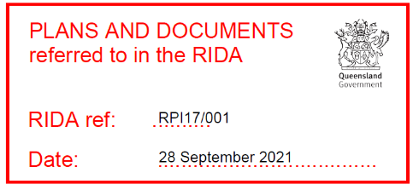
Attachment 2: 2021 Approved plans and specifications
3912/MPH10386, 1197/MPH25518, 1341/MPH25518, 1342/MPH25518,
1463/MPH10760, 2452/MPH1067, 3273/MPH11435, 3274/MPH11435,
3275/MPH11435, 3276/MPH11435, 3469/MPH11435, 5164/MPH10386,
18/RP602104, 17/RP602104, 1/MPH11169, 19/RP602104, Gordon Lane
Part D, USL waterways
Access A on SP164788 on Lot 203 on RN1556, Access B in Lot 1 on RP860374
9. Easements
7. Possible future exploration, rehabilitation
1/MPH10479, 1/MPH10850, 3/USL42977 B, 77/USL42977
6. Mine haul road, possible future exploration, rehabilitation
1/MPH10729, 2/MPH11057, 1/MPH11057, 103/USL42977 Part A, B, C
5. Mine haul road, mining resource for extraction, possible future exploration, rehabilitation
3/RP601353
4. Mine haul road, process plant, mining resource for extraction, possible future expln, rehabilitation, tailings storage
101/SP139776 (former 12/USL47036 in PLA)
3. Mining resource, mine haul road, rehabilitation, future exploration, tailings storage
Lot 1 on Plan RP860374
2. Mineral processing, haul road, mining resource for extraction, possible future expln, rehabilitation, tailings storage facility
1. Mining resource for extraction, rehabilitation and possible future exploration
Lot and Plan: 101/CP881492, 69/USL42977, 60/USL42977, 63/USL42977, 64/USL42977, 65/USL42977, 66/USL42977,
67/USL42977, 68/USL42977, 90/P42319

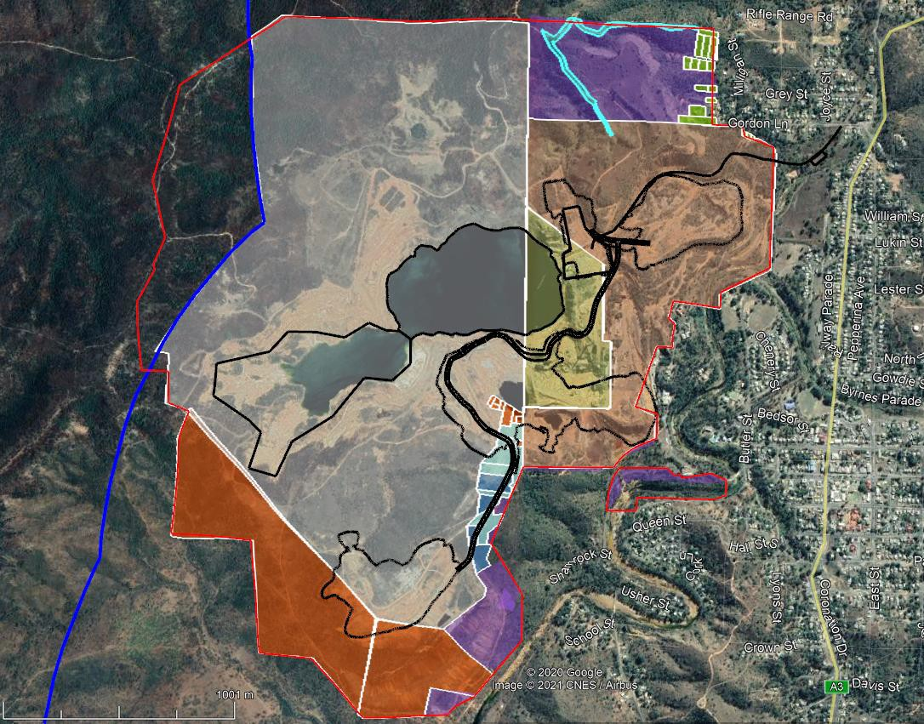
HERITAGE MINERALS ACTIVITY BY LOT AND PLAN
3912/MPH10386, 1197/MPH25518, 1341/MPH25518, 1342/MPH25518,
1463/MPH10760, 2452/MPH1067, 3273/MPH11435, 3274/MPH11435,
3275/MPH11435, 3276/MPH11435, 3469/MPH11435, 5164/MPH10386,
18/RP602104, 17/RP602104, 1/MPH11169, 19/RP602104, Gordon Lane
Part D
8. Inside mining lease but outside any location of current or future impact
Mine Haul Road

Dee River
Lot 90 on P42319
Lot 107 on CP881492
Gordon Lane mine access
Heritage Minerals resource activity footprint (May 2021)
PLA BOUNDARY
Lot 101 on SP139776 (former 12/USL47036)
Mundic & Red Oxide Tailings
Lot 3 on RP601353
Sandstone Gully Tailings Facility
Open Cut Pit
Process Plant Location
2 Mill Tailings
Lot 1 on RP860374
Lot 203 on RN1556
MINING LEASE BOUNDARY
Shepherds Tailings Resource
Attachment 2: Plans and specifications (2023 Amendment)

HERITAGE MINERALS ACTIVITY BY LOT AND PLAN LEGEND
3/RP601353
4. Mine haul road, process plant, mining resource for extraction, possible future expln, rehabilitation, tailings storage
101/SP139776 (former 12/USL47036 in PLA)
3. Mining resource, mine haul road, rehabilitation, future exploration, tailings storage
Lot 1 on Plan RP860374
2. Mineral processing, haul road, mining resource for extraction, possible future expln, rehabilitation, tailings storage facility
Lot and Plan: 101/CP881492, 69/USL42977, 60/USL42977, 63/USL42977, 64/USL42977, 65/USL42977, 66/USL42977,
67/USL42977, 68/USL42977, 90/P42319
1. Mining resource for extraction, rehabilitation and possible future exploration
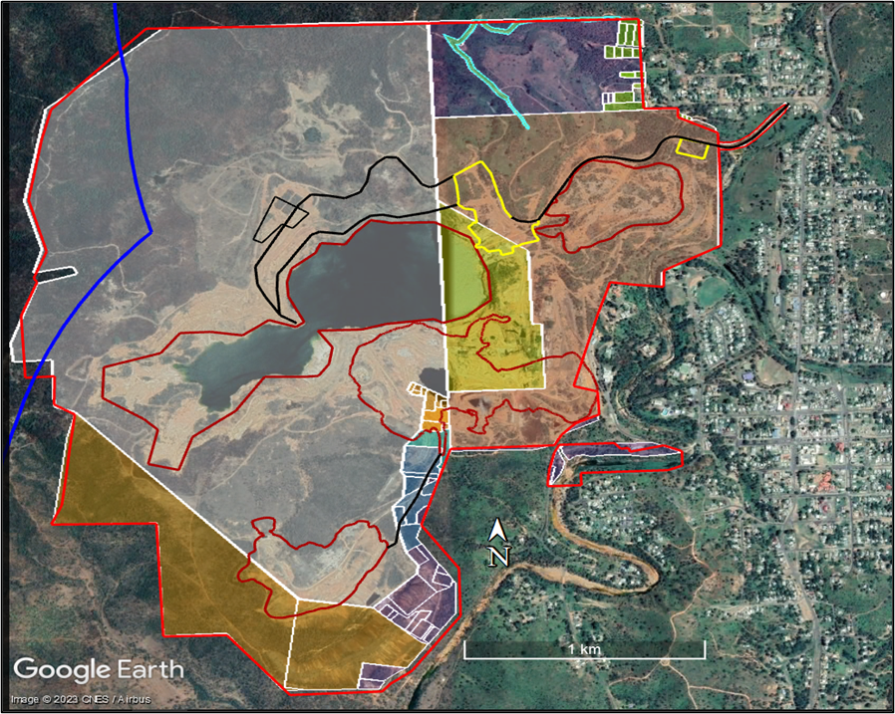
MINING LEASE BOUNDARY
Lot 203 on RN1556
Lot 101 on SP139776 (former 12/USL47036)
Gordon Lane access

PLA BOUNDARY
Process Plant location
Mine equipment park-up and Workshop
Lot 1 on RP860374

Admin/Lab/Carpark/WTP

2 Mill Tailings
Mine haul road upgrade
Open Cut Pit
1/MPH10729, 2/MPH11057, 1/MPH11057, 103/USL42977 Part A, B, C
5. Mine haul road, mining resource for extraction, possible future exploration, rehabilitation
Light vehicle access road
Lot 3 on RP601353

1/MPH10479, 1/MPH10850, 3/USL42977, 77/USL42977
6. Mine haul road, possible future exploration, rehabilitation
Mundic & Red Oxide Tailings
Sandstone Gully Tailings Facility
7. Possible future exploration, rehabilitation
Mine Haul Road
3912/MPH10386, 1197/MPH25518, 1341/MPH25518, 1342/MPH25518,
1463/MPH10760, 2452/MPH1067, 3273/MPH11435, 3274/MPH11435,
3275/MPH11435, 3276/MPH11435, 3469/MPH11435, 5164/MPH10386,
18/RP602104, 17/RP602104, 1/MPH11169, 19/RP602104, Gordon Lane
Part D
Dee River
Lot 107 on CP881492

3912/MPH10386, 1197/MPH25518, 1341/MPH25518, 1342/MPH25518,
1463/MPH10760, 2452/MPH1067, 3273/MPH11435, 3274/MPH11435,
3275/MPH11435, 3276/MPH11435, 3469/MPH11435, 5164/MPH10386,
18/RP602104, 17/RP602104, 1/MPH11169, 19/RP602104, Gordon Lane
Part D
8. Inside mining lease but outside any location of current or future impact

Access A on SP164788 on Lot 203 on RN1556, Access B in Lot 1 on RP860374
9. Easements
Heritage Minerals resource activity footprint (Amended February 2023)

Lot 90 on P42319

